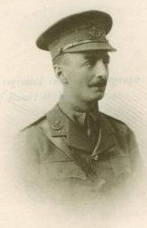 | 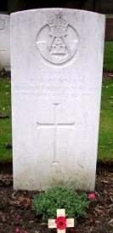
Robert William PEARSON
was the fourth son of the late R. Pearson of Tamworth. He was born at Whitchurch on June 22 1880, entered Oundle (Dryden House) in January 1894 and left in July 1897.
He was killed in action in Flanders on May 15 1915. He had been a keen Volunteer and Territorial and was the senior Captain of his Battalion, the Durham Light Infantry.
YPRES RESERVOIR Cemetery (IEPER) (West Vlaanderen Belgium) Grave IX.H.36.

